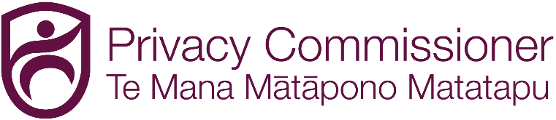

Statement of Intent

1 JULY 2026 TO 30 JUNE 2030

ISSN 2230-4290 (Print)
ISSN 2230-4304 (Online)


© 2026 Office of the Privacy Commissioner. This work is licensed under the Creative Commons Attribution 4.0 International license. In essence, you are free to copy, distribute and adapt the work, as long as you attribute the work to the Office of the Privacy Commissioner and abide by the other license terms. To view a copy of this license visit: https://creativecommons.org/licenses/by/4.0/
Presented to the House of Representatives pursuant to section 149 of the Crown Entities Act 2004

Contents
Foreword 3
Our strategic framework 5
Tuitui kākahu, tuitui tāngata 6
Our operating environment 8
The privacy system 8
The broad challenges before us 9
Our understanding of attitudes to privacy 11
Our purpose 12
Our functions 14
Our system outcomes 17
Individuals have a greater awareness of their privacy rights and use them more 17
Agencies can better achieve their own objectives by respecting the privacy rights of New Zealanders 19
There is increased confidence in New Zealand’s privacy system 20
Our objectives 21
We advocate for and empower people and communities who are more likely to be vulnerable to serious privacy harm 21
We provide direction and guidance to agencies that makes our expectations clear 21
We use our investigation and compliance powers to hold agencies to account for serious privacy harm 22
We take account of te ao Māori perspectives on privacy 22
Our values 24
Our organisational health and capability 25

Foreword

Privacy is precious. You might see it in a large event covered across all media outlets, such as a hacker stealing the health information of tens of thousands of New Zealanders. Privacy can also be felt in a small but deeply harmful event, such as a single mistaken disclosure leading to threats of violence and harm. Privacy is precious to all of us - we all have information that we want to protect.
This document sets out how my Office will strive to achieve its purpose of making privacy a core focus for all agencies. The scope of this vision is broad – it applies to companies, government departments and not-for-profits. But it is important too, as we are doing this to protect New Zealanders from harm, enable agencies to achieve their own objectives, and to safeguard our free and democratic society.
I do not underestimate the challenges before us. New privacy-intrusive technologies are constantly in development, the number of serious privacy breaches is increasing, and New Zealanders have high levels of concern about protecting the privacy of themselves and those they love.
Over the coming years, through our own efforts, and through collaboration with others, our aim is to see a nation where:
- Individuals have a greater understanding of their privacy rights and use them more.
- Agencies can better achieve their own objectives by respecting the privacy rights of New Zealanders.
- There is increased confidence in New Zealand’s privacy system.
To achieve this, we have set ourselves four objectives:
We advocate for and empower people and communities who are more likely to be vulnerable to serious privacy harm.
Our work to engage New Zealanders will improve the awareness and use of privacy rights. We will focus on those people and communities more likely to be vulnerable to serious privacy harm as we believe this is how we can effect the biggest change within our limited resources.
We provide direction and guidance to agencies that makes our expectations clear.
Agencies can only make privacy a core focus when they understand and have the capability to meet their privacy requirements. By setting clear directions and guidance, agencies that want to comply with the Privacy Act 2020 will be better able to respect the privacy rights of New Zealanders and achieve their own objectives.
We use our investigation and compliance powers to hold agencies to account for serious privacy harm.
Confidence in the privacy system requires a privacy regulator that holds agencies to account for serious non-compliance. While our ‘harder’ powers will always be a minority of the actions we undertake, their use will provide a warning to non-compliant agencies - and support to compliant agencies.
We take account of te ao Māori perspectives on privacy.
We must engage effectively with Māori to ensure that our significant work programmes appropriately consider and take account of te ao Māori perspectives. Doing so will enable us to not only act in accordance with the principles of the Treaty of Waitangi, but to better connect with Māori and Māori organisations.
The success of the strategy within this document will only be possible because of the dedication and passion my staff have for New Zealanders’ privacy rights. I look forward to working with them, and our stakeholders, as we work to ensure privacy and personal information is protected and respected in New Zealand.

Michael Webster
Privacy Commissioner
30 June 2026

Our strategic framework

Our purpose | Our purpose is to make privacy a core focus for agencies. We do this in order to protect New Zealanders from harm, to enable agencies to achieve their own objectives, and to safeguard our free and democratic society.
Our functions | - Communication and Connection  - Investigations and Dispute Resolution  - Policy and Advocacy  - Guidance and Education  - Compliance and Enforcement
Our system outcomes | - Individuals have a greater awareness of their privacy rights and use them more.  - Agencies can better achieve their own objectives by respecting the privacy rights of New Zealanders.  - There is increased confidence in New Zealand’s privacy system.
Our objectives | - We advocate for and empower people and communities who are more likely to be vulnerable to serious privacy harm.  - We provide direction and guidance to agencies that makes our expectations clear.  - We use our investigation and compliance powers to hold agencies to account for serious privacy harm.  - We take account of te ao Māori perspectives on privacy.
Our values | - Courageous  - Impactful  - Curious  - Nimble  - Professional

Tuitui kākahu, tuitui tāngata

The weaving of a cloak, the weaver of people
Our Office is increasingly expected to have a strong understanding and capabilities related to the Treaty of Waitangi / Te Tiriti o Waitangi, tikanga Māori and te ao Māori. In addition, the Privacy Act requires the Privacy Commissioner to take account of these perspectives in delivering on the Office’s functions. We recognise that to be an effective privacy regulator, we need to engage effectively with Māori, and to identify and respond to te ao Māori perspectives on privacy.
Tuitui kākahu, tuitui tāngata is a whakataukī that speaks to the process of weaving a kākahu or traditional Māori cloak and aligns that to the weaving of people. It is a whakataukī that works well in describing the privacy system, the role of our Office, and the place of the Treaty of Waitangi principles. This includes:
  - tiaki - protecting and safeguarding the privacy of all New Zealanders
  - taunaki - supporting the aspiration of rangatiratanga as expressed by Māori over their taonga, their data, and their privacy
  - tūhono - partnering with Māori.
Tuitui kākahu, tuitui tāngata describes the process of weaving and the completion of the garment, or cloak that can then be used by individuals, whānau, hapū, iwi, and Māori to protect their privacy.
This whakataukī represents how the principles of the Treaty of Waitangi and the Privacy Act work together to achieve the outcomes of the privacy system.
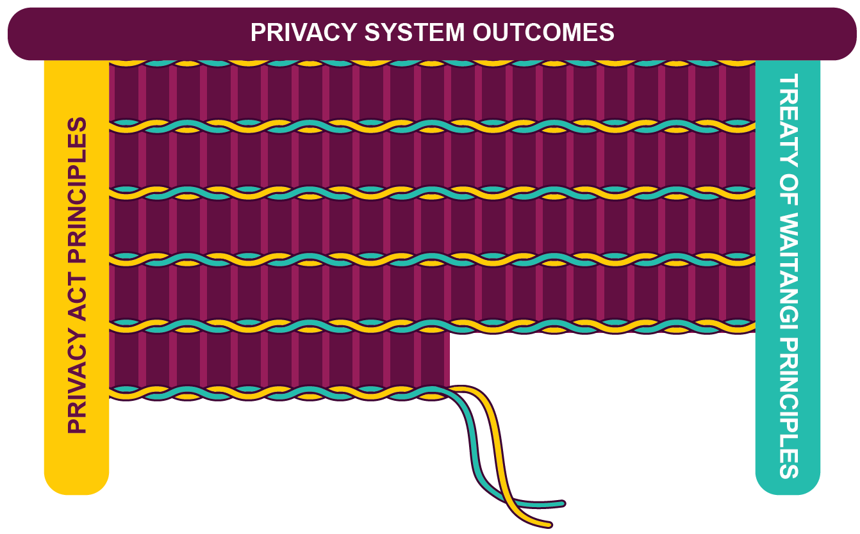

Our operating environment

The privacy system
Privacy is about an individual’s right to control their information, activities and personal space. The Privacy Act is focused on informational privacy - it regulates how agencies can collect, store, use and share the personal information of individuals. These agencies can be in the public, private or not-for-profit sectors.
We are the regulator of the privacy system – the flows of personal information between individuals and agencies throughout New Zealand. At the core of this system are the countless everyday interactions between individuals and agencies. Our Office is regulator of the privacy system, with our role including the issuing Codes of Practice and guidance, investigating the compliance of agencies with their requirements and investigating privacy complaints that individuals make to the Privacy Commissioner.
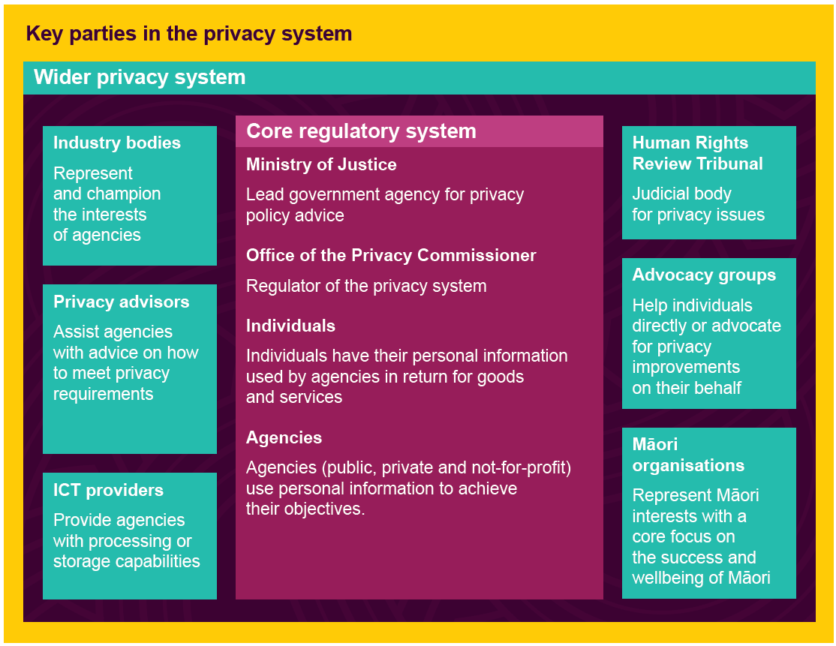

The broad challenges before us

Privacy is highly contextual
Successfully managing privacy is not a tick box exercise and there is no one size fits all. Good privacy practice requires that agencies have carefully considered policies, information technologies, and operational activities that take account of privacy in light of their particular environment.

The importance of privacy and the impact of breaches varies
Our diverse country means that a single privacy breach can impact a range of people very differently. Some will be more vulnerable to serious harm and in greater need of assistance, while others will have the resources to better protect themselves. Some people care deeply about maintaining their privacy, while others are less concerned.

The agencies we regulate are many and varied
Our regulated sector is very broad, extending to nearly the entire public, private and not-for-profit sectors. Many agencies have a low understanding about managing privacy well, especially if they are very small. While market incentives will mean that some agencies prioritise privacy, strong action from our Office will be required to make privacy a core focus across the entire privacy system.

Technology is rapidly changing
There is strong uptake of new technologies like facial recognition technology and artificial intelligence. While these technologies are bringing significant benefits to both individuals and agencies, they are also introducing new and novel privacy risks that need to be managed if we are to minimise privacy harm.

The frequency and impact of privacy breaches is increasing
The digital age means greater volumes of personal information being collected, used and disclosed between agencies. There has also been an increase in privacy breaches and complaints being notified to our Office, placing us under increasing pressure.

Internationally, privacy is increasingly important
With countries increasingly viewing data as competitive advantage, it is important to have an internationally well-regarded privacy regime. While New Zealand’s small size limits our international influence, many of our issues are common to other jurisdictions, meaning we do not need bespoke New Zealand solutions.

Our understanding of attitudes to privacy
Since 2001, our Office has surveyed the public to measure awareness, knowledge, and levels of concern regarding privacy and the protection of personal information. Over the past 25 years there have been large changes in the expressed concern about privacy.
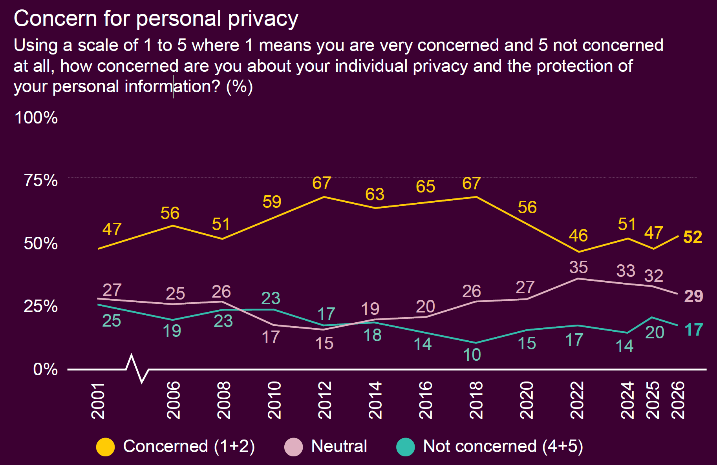
New Zealanders also have very different levels of concern about specific privacy issues. In 2026, there were high degrees of concern about a range of issues:
- 71% - The privacy of children, including when they use social media
- 67% - Government agencies or businesses using artificial intelligence to make decisions about them, using their personal information
- 65% - The management of personal information by social media companies
- 56% - The security of health information
- 53% - Different government organisations combining personal information they hold to create a single view of each person
- 53% - The potential biases of facial recognition technology, for example racial or gender biases leading to misidentification
- 51% - The introduction of digital identity systems, cards or numbers
- 47% - The use of facial recognition technology to identify individuals in retail stores
- 45% - The use of facial recognition technology by law enforcement to identify individuals in public spaces

Our purpose
Our purpose is to make privacy a core focus for agencies. We do this in order to protect New Zealanders from harm, to enable agencies to achieve their own objectives, and to safeguard our free and democratic society.
Agencies are central to our purpose because of their importance in protecting personal information. No matter their size, personal information is held and used by every company, not-for-profit, government department, Crown entity and council in New Zealand. Improving the capabilities, understanding and importance of privacy within agencies will deliver the largest possible improvements to privacy outcomes.
The good management of personal information should be a core focus for agencies, in the same way as financial reporting and health and safety. Agencies who do privacy well will grow the trust of their clients, customers and employees - and reduce the harms arising from privacy breaches.
Our entire Office contributes towards this common purpose, and we have set ourselves four objectives to accomplish:
- We advocate for and empower people and communities who are more likely to be vulnerable to serious privacy harm.
- We provide direction and guidance to agencies that makes our expectations clear.
- We hold agencies accountable for serious privacy harm through using our investigation and compliance powers.
- We take account of te ao Māori perspectives on privacy.

How we contribute to Ministry of Justice priorities
The work of our Office also contributes to the broader outcomes of the Ministry of Justice, which are:
- Trusted and legitimate
That New Zealanders trust, view as legitimate, and have confidence in the outcomes of the justice and constitutional systems.
- Accessible and effective
Ensuring that people and businesses that seek to resolve disputes or seek justice can use the legal system to obtain an outcome by means of a fair and open process.
- Safe and prosperous society
Allowing people to live without fear, participate fully in society, and pursue opportunities without worry about potential harm.

Our functions
We promote and protect individual privacy through regulating the Privacy Act and the Codes issued under it. As an independent Crown entity under the Crown Entities Act 2004, the Privacy Commissioner has independence when undertaking a wide range of activities across government, business and society.
We have the following functions:

Communication and Connection
This function focuses on growing the awareness that New Zealanders have of their privacy rights.
- We use our website and brochures to inform people about their privacy rights in a simple and concise way.
- We promote privacy awareness through engaging New Zealanders, both in person and through the media, on issues of public and media interest.
- We undertake engagement focused on those parts of society more likely to be vulnerable to serious privacy harm.

Investigations and Dispute Resolution
This function focuses on investigating privacy complaints that we receive from individuals under Part 5 of the Privacy Act.
- We use dispute resolution techniques for individual complaints and, where we can, encourage the settlement of a complaint between the parties.
- We undertake full investigations where necessary and appropriate, and refer serious cases to the Director of Human Rights Proceedings to consider bringing to the Human Rights Review Tribunal.
- Where appropriate, we can direct agencies to provide individuals access to their personal information.

Guidance and Education
This function focuses on building the ability of agencies to understand their privacy responsibilities.
- We provide comprehensive and clearly written guidance to agencies.
- We provide e-learning modules so that employees of agencies can build their privacy knowledge.
- We promote the importance and understanding of privacy through events, conferences, and stakeholder engagement.

Compliance and Enforcement
This function focuses on incentivising agencies to meet their privacy requirements.
- We proactively identify and investigate systemic issues for possible intervention.
- We receive breach notifications and follow up with agencies on those likely to cause serious harm.
- We undertake monitoring and compliance activities, such as issuing compliance notices, to ensure compliance with the Privacy Act and prosecute offenders if required.

Policy and Advocacy
This function focuses on maintaining the Codes of Practice issued under the Privacy Act and reviewing the privacy implications of the Government’s legislative programme.
- We provide advice to the Government on new legislation and policy proposals, including for government information sharing.
- We set clear expectations for agencies through clear positioning of our Office as a regulator and reviewing Codes of Practice.
- We advocate for privacy positive outcomes, including through championing reform to the Privacy Act.

Our responsibilities as a regulator under the Customer and Product Data Act 2025
The Customer and Product Data Act 2025 empowers New Zealanders to authorise businesses to transfer their information to another business in a specified format. The Government has prescribed the banking sector as the first sector covered by this Act, with the electricity sector likely to follow.
Our Office is the privacy regulator under this Act, which has been designed to align with and complement the Privacy Act. The Commissioner’s role includes investigating complaints and taking compliance action in relation to privacy related breaches. As privacy and public trust will be essential to the sharing of customer information and the success of the Customer and Product Data Act, the Privacy Commissioner will promote public understanding and trust in the personal information protections supporting the transferal of customer information.

Our system outcomes

Individuals have a greater awareness of their privacy rights and use them more
Privacy is important, with privacy breaches causing a lot of harm every year, whether emotional, reputational, financial, or physical. To illustrate, when the Human Rights Review Tribunal has considered privacy cases and determined there should be a financial settlement, the average settlement amount for emotional harm or injury to feelings was over $21,000. The harms to specific people can be far higher; for example, in 2024 we reported on a small business phishing attack that involved one client losing over $100,000 due to the breach.
The Privacy Act provides individuals with important privacy rights such as the rights to access and correct personal information that an agency holds about them and to seek corrections. These rights directly benefit individuals through providing them with more control over their personal information, which can be valuable. For example, survivors of abuse in care were able to exercise their privacy rights to gather records about their experiences to help them understand what happened and to participate in the Abuse in Care Royal Commission of Inquiry.
Individuals who understand and use their privacy rights can incentivise agencies to better safeguard personal information. For example, our 2026 privacy survey found that two-thirds of New Zealand adults stated they would likely change service providers if they heard that provider had poor privacy and security practices. Through increasing the awareness and use of privacy rights of New Zealanders, we will be encouraging agencies to make privacy a core focus - and reducing the privacy harms experienced by New Zealanders.

How we will assess this outcome
We consider that awareness of the right to access personal information is an important indicator of wider privacy awareness and comfort in exercising privacy rights. As a part of taking account of te ao Māori perspectives on privacy we will separately track Māori awareness of their access right.
Indicator | Baseline (year) | Direction of travel
Public awareness of right to access personal information under the Privacy Act | 55% (2026) | Increase
Māori awareness of right to access personal information under the Privacy Act | 56% (2026) | Increase

Agencies can better achieve their own objectives by respecting the privacy rights of New Zealanders
Personal information is provided to agencies so that they can produce goods or services, whether for a public service or to make a profit. The importance of privacy to an agency can vary. For government agencies, privacy contributes to the public trust and social licence that supports their activities. For some businesses privacy can be a competitive advantage in the market, while other businesses may only be interested in avoiding expensive privacy breaches.
A universal theme for all agencies is the cost of privacy breaches. When a breach occurs, the agency must address the immediate cause, important data may have been lost, and there could be a loss of existing customers or clients. The Privacy Act also requires that agencies notify the Privacy Commissioner and affected individuals if a privacy breach is likely to cause serious harm.
Our research into cyber insurance found that for New Zealand businesses, the average value of a cyber insurance claim involving personal information is $150,000. The cost of large breaches can far exceed this value. For example, Latitude Financial reported that their 2023 data breach, which affected over one million New Zealanders, had cost them $68.3 million Australian dollars.

How we will assess this outcome
Agencies must have a good understanding of privacy requirements if they are to respect the privacy rights of New Zealanders. We consider that a proxy indicator of agency understanding is how fast our Office is notified of privacy breaches likely to cause serious harm. We will also survey whether New Zealanders consider that their privacy rights are being respected.
Indicator | Baseline (year) | Direction of travel
Percentage of serious privacy breaches notified to our Office within 72 hours | 61% (2022) | Increase
The public consider that the organisations they deal with respect their privacy rights. | 59% (2026) | Increase

There is increased confidence in New Zealand’s privacy system
The outcomes of the privacy system extend beyond the direct interactions between individuals and agencies. Confidence in New Zealand’s privacy system, including the Privacy Act, contributes to trust in public institutions as New Zealanders believe their personal information will be well treated. This trust in turn helps drive better outcomes by encouraging engagement in democratic and consultation processes, helping to inform the design of effective services, and tackling complex problems.
International confidence in the privacy system also provides significant value to New Zealand. For example, from 2012 New Zealand has had ‘adequacy status’ from the European Commission under the European General Data Protection Regulation. This status lowers compliance costs for New Zealand agencies as they do not need to put in place additional privacy safeguards (such as contractual clauses) when undertaking trade with the European agencies. The adequacy status has also helped to facilitate cross border agreements to support policing, such as with Europol (the European Union Agency for Law Enforcement Cooperation).
Building confidence in the privacy system is an outcome that we contribute to through being an effective privacy regulator. However, there are factors that are outside of our direct control. For example, continued technological developments means it is important that the Privacy Act is modernised and is fit-for-purpose. This in turns emphasises the importance of our role as an advocate for privacy in New Zealand.

How we will assess this outcome
We will use our privacy survey as an indicator of domestic confidence in the privacy system, which is built on actions of the entire privacy system (not just our Office). Internationally, maintaining New Zealand’s adequacy status will remain important.
Indicator | Baseline (year) | Direction of travel
Percent of the public that are moderately, very or extremely confident that New Zealand law adequately protects personal information. | 59% (2026) | Increase
New Zealand’s privacy system is regarded as adequate by like-minded countries | European Union adequacy status (2012) | Maintain

Our objectives

We have set four objectives to help us achieve our outcomes

We advocate for and empower people and communities who are more likely to be vulnerable to serious privacy harm
Functions that directly support this objective: Communication and Connection.
Our work to engage New Zealanders will improve the awareness and use of privacy rights. There are a range of people and communities more likely to be vulnerable to serious privacy harm and this can relate to demographic factors such as age, ethnicity, disability, sexuality or gender. Being vulnerable can also be situational, such as being a vulnerable patient or migrant worker. We will focus on those people and communities more likely to be vulnerable to serious privacy harm as we believe this is how we can effect the biggest change within our limited resources.
Over the course of the next four years, our activities will include:
- implementing engagement programmes to reach parts of society more likely to be vulnerable to serious privacy harm
- continuously improving the accessibility and usefulness of our brochures and website material targeted at New Zealanders
- advocating for important new privacy rights through Privacy Act modernisation.

We provide direction and guidance to agencies that makes our expectations clear
Functions that directly support this objective: Policy and Advocacy, Guidance and Education.
Agencies can only make privacy a core focus when they understand and have the capability to meet their privacy requirements. By setting clear directions and guidance, agencies that want to comply with the Privacy Act will be better able to respect the privacy rights of New Zealanders and achieve their own objectives.
Over the course of the next four years, our activities will include:
- providing guidance to agencies on important Privacy Act requirements and technological developments
- meeting our regulatory stewardship responsibilities through reviewing Privacy Act Codes of Practice
- providing targeted one-to-one assistance to agency projects that will have a large impact on privacy system

We use our investigation and compliance powers to hold agencies to account for serious privacy harm
Functions that directly support this objective: Investigations and Dispute Resolution, Compliance and Enforcement.
Confidence in the privacy system requires a privacy regulator that holds agencies to account for serious non-compliance. While our ‘harder’ powers will always be a minority of the actions we undertake, their use will provide a warning to non-compliant agencies - and support to compliant agencies.
Over the course of the next four years, our activities will include:
- promptly triaging privacy complaints and breach notifications to help focus our activities on areas of serious privacy harm
- using the full range of powers available to us to hold agencies to account
- updating our IT systems to improve the efficiency and effectiveness of our Compliance and Enforcement and Investigations and Dispute Resolution functions.

We take account of te ao Māori perspectives on privacy
This is a cross-cutting objective that all our functions support.
The Privacy Act requires the Privacy Commissioner to take account of cultural perspectives on privacy when performing any statutory function or duty and in exercising any statutory power. The privacy surveys that we commission also show that Māori are more concerned about privacy and personal information than other New Zealanders.
Taking account of te ao Māori perspectives on privacy will enable us to not only to act in accordance with the principles of the Treaty of Waitangi, but to better connect with Māori and Māori organisations. We will work to ensure that our significant work programmes appropriately consider and take account of te ao Māori perspectives.
Over the course of the next four years, our activities will include:
- continuing our staff training on te Rēo Māori, tikanga, and kawa
- consulting on our work with our Māori reference panel, Te Ranga Tautiaki
- implementing an engagement programme focused on engaging Māori on their privacy rights.

Our values

Courageous
- We focus on doing the right thing/what’s right and acting with integrity.
- We speak up and take action to protect New Zealanders’ privacy rights.
- We are prepared to take informed risks in pursuit of strategic opportunities.

Nimble
- We are savvy, agile and adaptable.
- We are responsive, able to pivot quickly when needed to meet demands.
- We are confident navigating complexity and ambiguity.

Impactful
- We look to work which will have the highest impact in line with our strategy.
- We are results orientated.
- We set ourselves ambitious goals.

Professional
- We take pride in our role as New Zealand’s independent privacy regulator.
- We go about our work in a collaborative and transparent manner.
- We are committed to taking actions which are fair, ethical and impartial.

Curious
- We are forward looking.
- We relentlessly seek out better ways to achieve our purpose.
- We welcome different perspectives and stay open to new ways of thinking.

Our organisational health and capability

Working together as an inter-connected Office
We will work systemically across our Office so that we allocate and prioritise our resources to aid decision making and achieve the best results. Each of our functions (including our support functions) will bring unique perspectives and skills that enable us to achieve our vision.
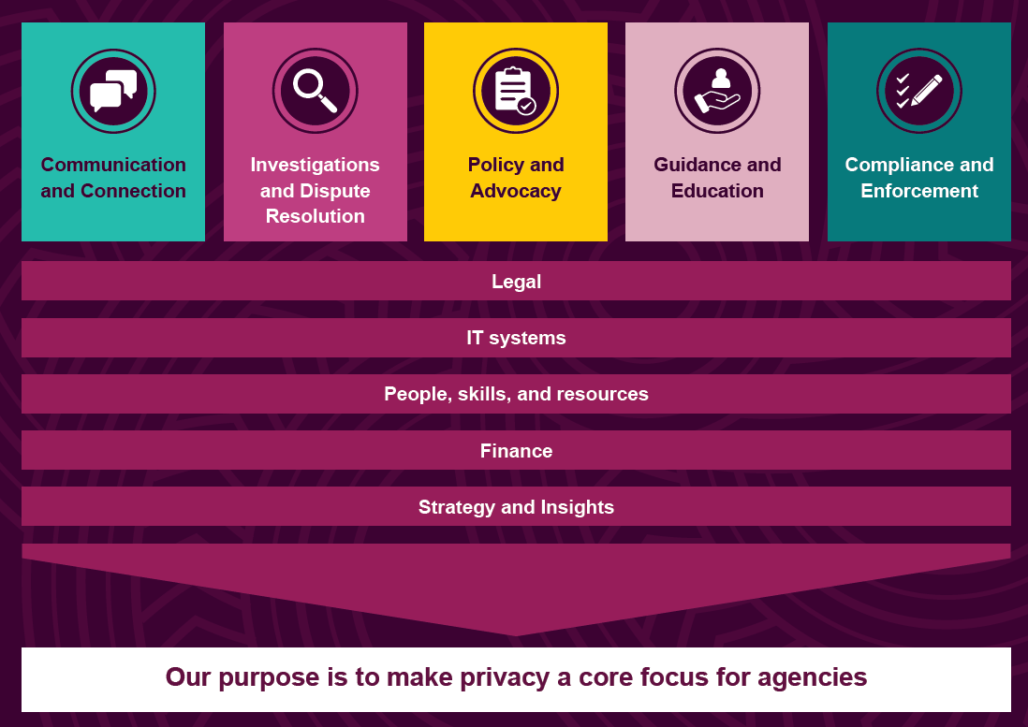
We will strive for evidence-based decision making by conducting robust analytics reports on our information holdings as well as informing our work with international insights. We will seek to invest in our information technology, upgrading our digital services channels and content and customer management systems.

Working with other regulators to protect privacy
There is much that we can learn from privacy regulators in other countries, and there are regulators in New Zealand who have responsibilities that overlap with the privacy system (as their regulatory systems collect, use, and share personal information).
We will better promote and protect privacy by working with other regulators. These could be regulators of privacy-adjacent areas in New Zealand (such as consumer protection) or privacy regulators in other countries. Connecting with regulators enables us to pool resources, share wisdom and practice, and to learn from others. In addition, effective implementation of good privacy practices requires buy-in from others.

Maintaining highly skilled and engaged staff
As a relatively small organisation, continuing to attract and keep talented people is critical for our ongoing success. Our yearly staff survey results show us to be a great place to work, with positive ratings from our people for the importance and impact of our work, confidence in our expertise as privacy professionals, great organisational culture, and for our ongoing investment in te ao Māori cultural capability for our staff.
Building on these results, we will continue our focus on sustaining a positive workplace culture, including actions which:
- support a talent pipeline capable of meeting our future needs
- reflect and support a diverse and inclusive workforce
- are aligned to our health, safety and wellbeing goals with a particular focus on a psychologically safe workplace climate (or mentally healthy work)
- support staff professional growth and performance recognition
- position us as an employer of choice
- provide opportunities for staff engagement.

Equal employment opportunities and good employer statement
The Privacy Commissioner has an Equal Employment Opportunities (EEO) policy and is committed to being an inclusive employer with fair and equitable employment practices.
We assess our status as a good employer against the elements and criteria set out by the Human Rights Commission. Over the next four years we will continue to assess and develop people and culture actions in support of our EEO targets and aspirations.
Key Employment Elements are reported on through the Annual Report.
Our Kia Toipoto Pay Gaps Action Plan is available on our website.

AK Research and Consulting, Research on Privacy Concerns and Use of Personal Information (April 2026)
Office of the Privacy Commissioner, Annual Report 2024.
AK Research and Consulting, Research on Privacy Concerns and Use of Personal Information (April 2026)
AK Research and Consulting, Research on Privacy Concerns and Use of Personal Information (April 2026)
AK Research and Consulting, Research on Privacy Concerns and Use of Personal Information (April 2026)
Latitude Annual Report 2023, Latitude Group Holdings Limited
AK Research and Consulting, Research on Privacy Concerns and Use of Personal Information (April 2026)
AK Research and Consulting, Research on Privacy Concerns and Use of Personal Information (April 2026)
Privacy Act 2020, s 21(c)

