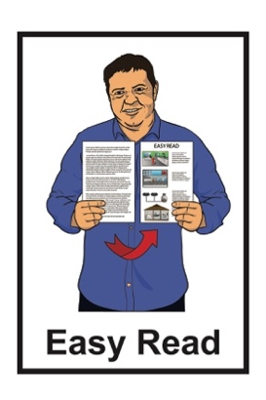
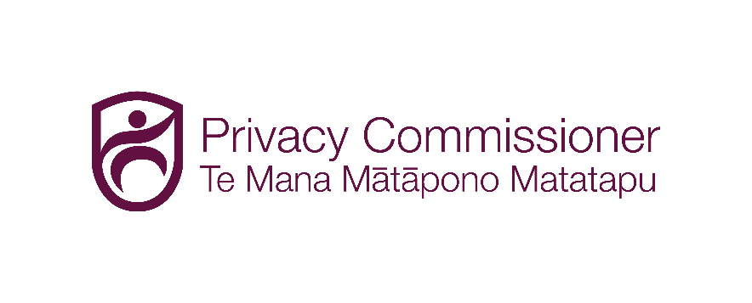

Your privacy rights
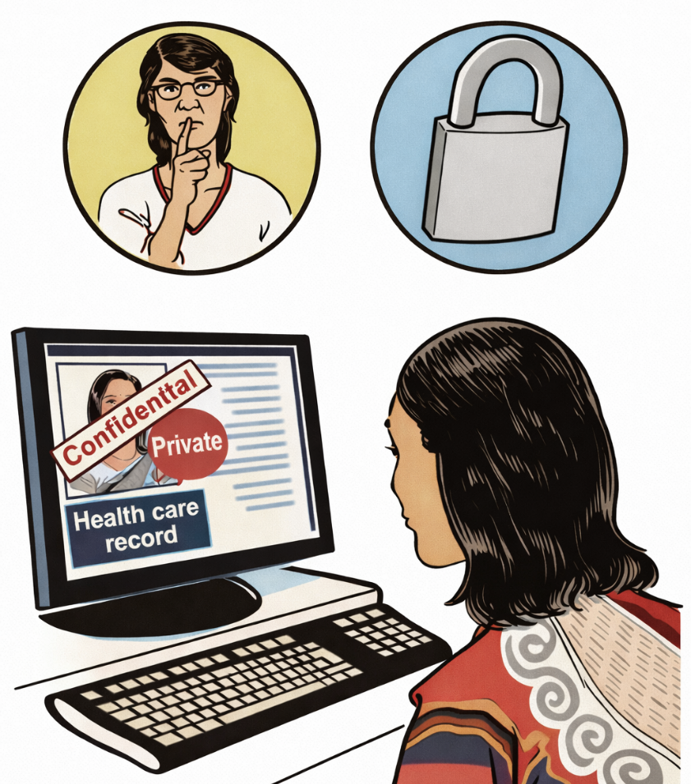

Published: March 2026

About this document

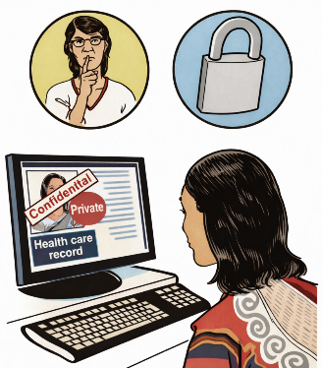
This Easy Read document is about your privacy rights.

Here privacy rights means keeping information about you safe.

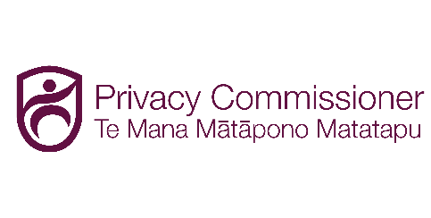
This Easy Read document is from the Office of the Privacy Commissioner.

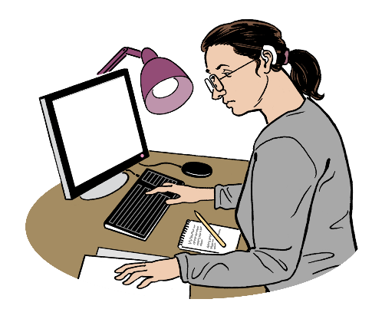
The Office of the Privacy Commissioner deals with complaints about your privacy rights.

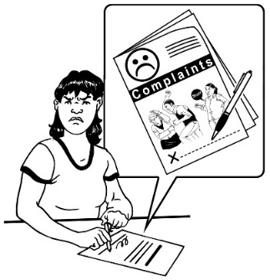
Complaints are when you are not happy with how your private / personal information has been
looked after.

Did you know you have privacy rights?


The law says organisations who keep any personal information that can identify you must keep it safe.

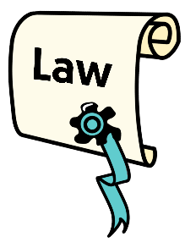
Here the law means the rules of New Zealand that everyone must follow.


Information that can identify someone means information that can be used to find out who someone is.


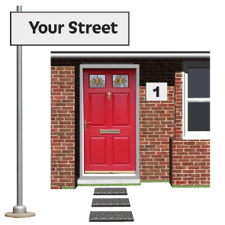
You name does not need to be used for something to be personal information.


Some things that could have personal information are:

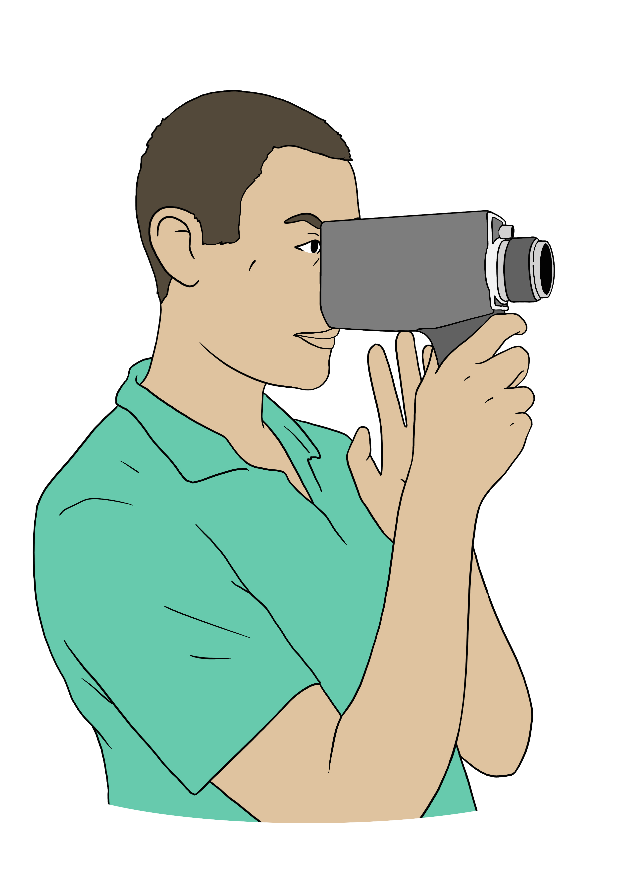
notes about you
emails
recordings
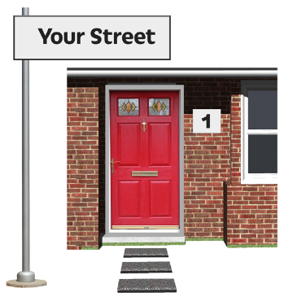
photos
things that say your address
things that have information that could only be about you.

The Privacy Act 2020 is the law that keeps your personal information safe.


It is our job to make sure organisations follow the
Privacy Act 2020.

Asking for your information

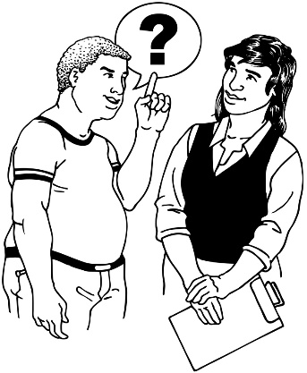
The Privacy Act gives you the right to ask for personal information that organisations have about you.


You can ask for your information from any New Zealand:
organisation
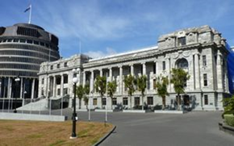
business
government agency.


You can also ask them to change the information if it is wrong.

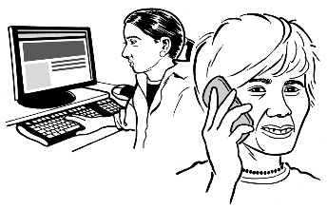
How to ask for your information

You can ask for your information by:
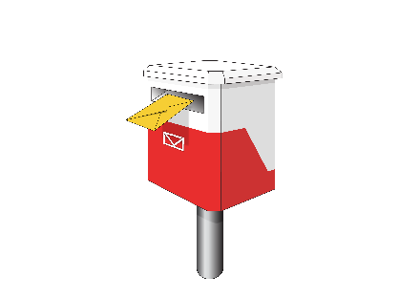
email
phone

letter
asking in person.

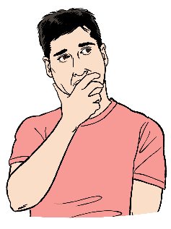
When you ask for your information you need to say things like:
what information you want

what your full name is
when the information you want might have been written.

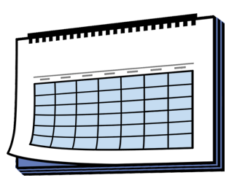
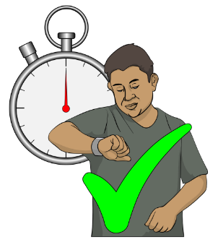
You should hear back from them in no more than 20 working days.

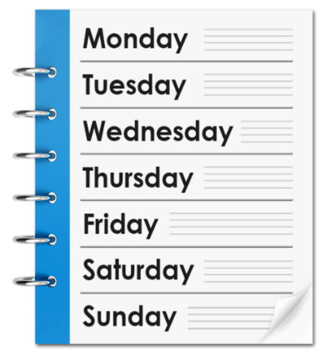
Working days means the days of
the week from Monday to Friday.

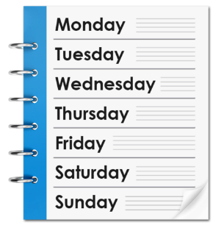
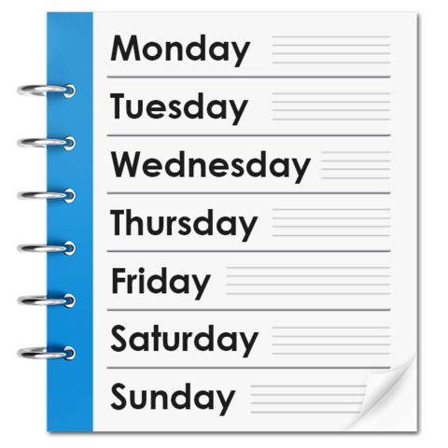
Saturday and Sunday are not working days.

This means there are
10 working days in 2 weeks.


You should not be charged any money to get your information most of the time.

Our AboutMe form
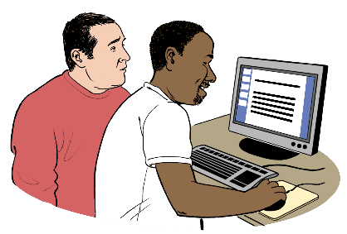
Our website has an online form called AboutMe.

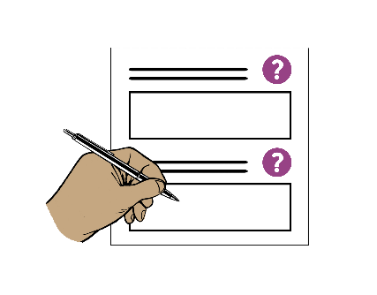
It can support you to contact the group you want your information from.

You do not have to use this form to ask for your information.


We do not get a copy of the AboutMe form you fill out.

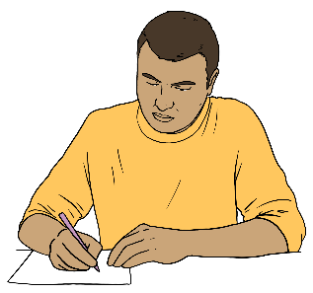
You will need to keep any information about the form you may need.

The AboutMe form asks:
your name
how to contact you like on the phone

what information you want to know.

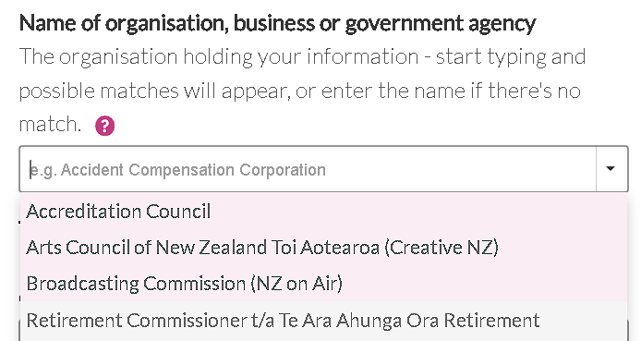
We have listed some groups a lot of people need information from.

You can choose 1 of these groups from the dropdown menu.

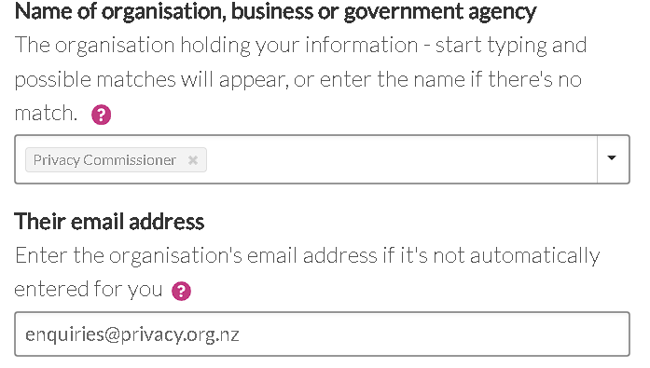
The AboutMe form will fill in the group email if you choose them from the dropdown menu.

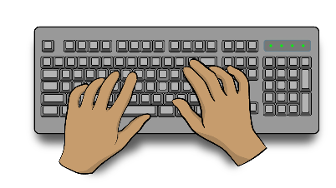
If the group you want to contact is not listed in the dropdown menu you will need to type in:
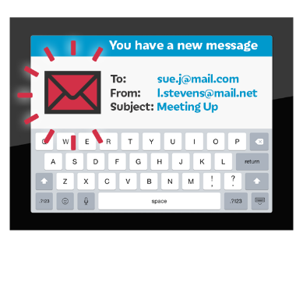
the group name
their email address.


You can find the AboutMe form on our website at:

www.tinyurl.com/RequestYourInfo

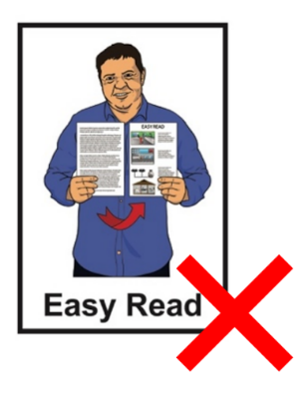
This form is not in Easy Read.

What to do if someone leaks your

personal information

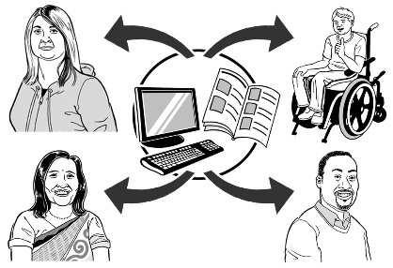
An organisation cannot leak your personal information.

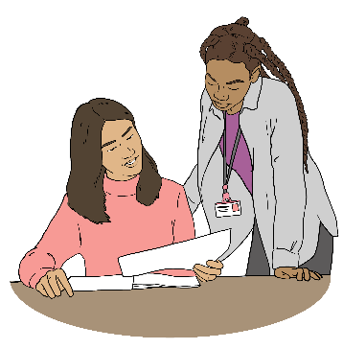
Here to leak information means to share personal information without getting consent from the person it is about.

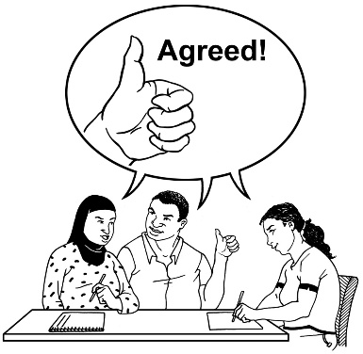
Here consent means agreeing that a group can share your personal information with someone else.


If they leak your personal information you need to:
contact them first

and
try to fix the problem.

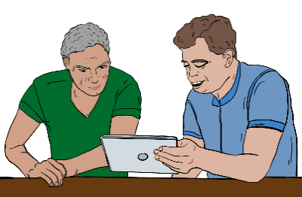
If contacting them does not work you can contact us for support.

How to contact us
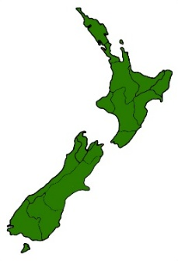

Everyone in New Zealand has privacy rights.


It does not cost any money to make a privacy complaint.


You can make a complaint by filling out a form on our website at:

https://tinyurl.com/OPCSelfAssess
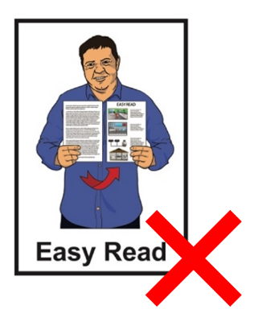

This website is not in Easy Read.

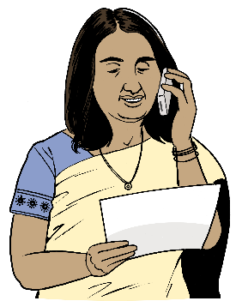
You can also make a complaint by calling us on:
0800 803 909


If you find it hard to use the phone the New Zealand Relay service is for people who are:
Deaf / hard of hearing
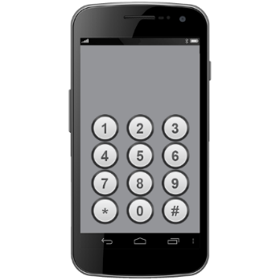
deafblind
speech impaired / find it hard to talk.

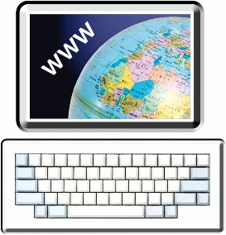
You can find out more about the New Zealand Relay service at:

www.nzrelay.co.nz

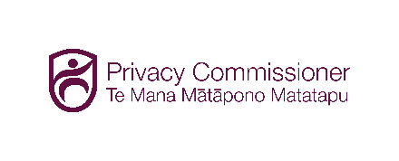
This information has been written by the Office of the Privacy Commissioner.

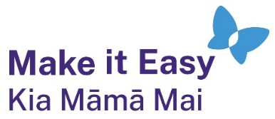
It has been translated into Easy Read by the Make it Easy Kia Māmā Mai service of People First New Zealand Ngā Tāngata Tuatahi.

The ideas in this document are not the ideas of People First New Zealand Ngā Tāngata Tuatahi.

All images used in this Easy Read document are subject to copyright rules and cannot be used without permission.


Make it Easy uses images from:


- Photosymbols

- Change Images

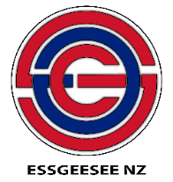
- Huriana Kopeke-Te Aho

- SGC Image Works

- T Wood


- Studio Rebeko

- Inga Kramer.

